**D)**

**1)Betty: - - - - ?**

**Adam: She was an important scientist. She discovered radium and polonium.**

a) Did Marie Curie get married

b) Where was Marie Curie born

c) When did Marie Curie die

d) Who was Marie Curie

**2)You are very ………………….. You never change your mind or ideas**.

|  |  |
| --- | --- |
| A)generous C) thoughtful  B) stubborn D) easy-going |  |

**3)Caretta Caretta turtles are in danger.**

**We should ………………………**

|  |  |
| --- | --- |
| A)go hunting  B)sell them as pets  C)protect their habitats  D)plant more trees |  |

**4)According to the table, find the correct sentence.**

|  |  |  |  |
| --- | --- | --- | --- |
|  | Scuba diving | Football | Table- tennis |
| **Halil** | ** | *** | --------- |
| **Sedef** | *** | -------- | ** |
| **Azra** | -------- | ** | *** |

---- never ** sometimes ***often

A)Halil often goes scuba-diving.

B)Sedef never plays table tennis.

C)Azra sometimes plays football.

D)Halil often plays table tennis.

**5)Complete the table.**

|  |  |
| --- | --- |
| **Appearance** | **Personality** |
| attractive | generous |
| 1………….. | 2…………… |

A) punctual/ well-built C) stubborn/ forgetful

B) overweight/ stubborn D) tall/ slim

**6)It looks like a horse with black and white stripes. It is a ……………..**

A)Horse B)Panda C) Giraffe D)Zebra



**7)It is - - - -**

a) surfing b)sailing

c) scuba diving d)skating

**8)What kind of TV programme is it ?**



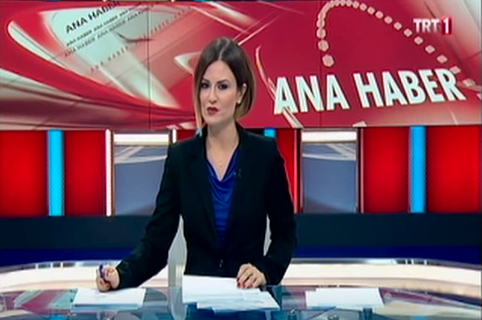

a) reality show

b) news

c) discussion

d) cookery show

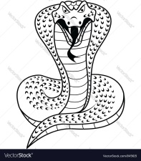**9)Verilen metinde hangi sorunun cevabı yoktur?**   
  
***It’s a king cobra. It lives in Asia. It’s 6,5m long. It is a reptile. It’s a carnivore. It eats rats and other snakes. It lives about 20 years.***A) How much does it weigh?  
B) Where does it live?   
C) How long does it live?  
D) What does it eat?   
  
10)**My mother hates football. She ………. watches football matches.**

A) always B) often  
 C) usually D) never

**11)I need my swimming cap and ………. I am going diving**

1. cleats c) rackets
2. goggles d) gloves

**12)Beşiktaş 3-Galatasaray 0**

**Beşitaş ……. Galatasaray 3-0**

A)lostB)defeated C) attackedD) won