Yazilidayim.net İNGİLİZCE SINAVI A
NAME SURNAME: CLASS: NUMBER:

1- Jackie Chan is from......., he is..... .
a)Germany/German b)Spain/Spanish c)China/Chinese d)Chinese/China

2-Donald Trump is a(n) .......... . He is from ............
a)American/the USA b)English/ England
c)the USA/American d)America/English

3- A(n)............ works in a laboratory.
a)teacher b)waitress
c)chemist d)accountant

4- Boşlukları “a/an” ile doldurunuz.
........umbrella, ........mobile phone,
........passport, .........ID card.
a)a/a/an/an b)an/a/a/an
c)an/an/a/an d)a/an/an/a

5. 6. ve 7. Soruları Aşağıdaki Tabloya Göre Cevaplayınız.
 | A notebook | A student ID card | Bottle of water | A car
Sergio | + | - | - | +
Katia | + | + | - | +
Hillary | - | - | + | +
Emily | + | + | + | -

5- Sergio ........ a notebook but he .......a student ID card.
a)have got/haven’t got b)hasn’t got/haven’t got
c)has got/has got d)has got/ hasn’t got

6- Emily ........a car but Hillary and Katia ......cars.
a)Hasn’t got/have got b)has got/haven’t got
c)has got/have got d)have got/haven’t got

7-Hillary and Emily ........bottle of water but Sergio and Katia ......... bottle of water.
a)has got/hasn’t got b)have got/haven’t got
c)haven’t got/have got d)have got/hasn’t got

8- We can go out late in Elmadağ, because it is ........ but we can’t go out late in İstanbul , because it is ....... .
a)crowded/uncrowded b)safe/unsafe
c)busy/quiet d)safe/safer

9-Do you like going to cinema with your friends at the weekends?
a)Yes, I do. b) Yes, my friends do.
c)Yes, I likes. d) Yes, you dislike.

10- What time .......you.......in the mornings?
a)does/gets up b)do/gets up
c)do/get up d)do/getting up

11- What type of movies do you like watching?
a)I hate comedy films.
b)I like sci-fi movies.
c)I dislike romance movies.
d)I likes horror movies.

12-
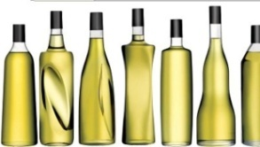
..............a book but ................ a phone.
a)There is/there isn’t b)There are/there isn’t
c)There isn’t/ there are d)There isn’t/there is

13-Brian ........ like eating fish and chips.
a)do b)doing c)don’t d)doesn’t

14- Gruplandırıldığında hangisi dışta kalır?
a)coffee table b)armchair c)sofa d)sink

15- Gruplandırıldığında hangisi dışta kalır?
a)fridge b)armchair c)cooker d)sink
16- Doğru sıralamaya uygun yer yön zarflarını seçiniz.
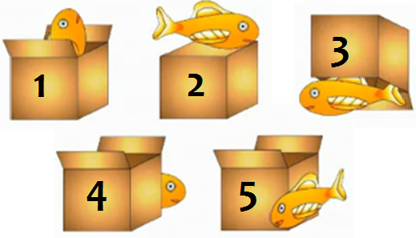
a)in/on/under/behind/next to
b)in front of/onto/in/behind/near
c)on/in/under/behind/near
d)in/under/on/behind/next to

17- Which is wrong about Tokyo? Tokyo hakkında hangisi yanlıştır?
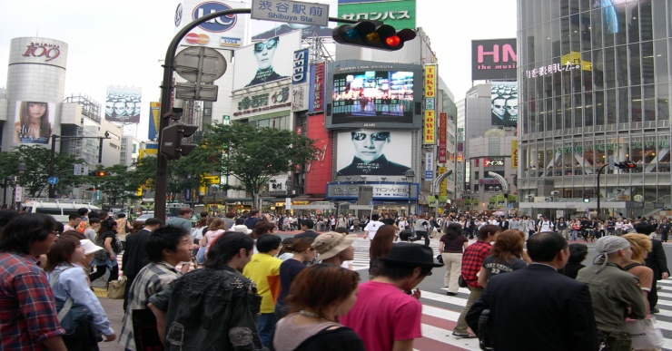
a)crowded and unsafe
b)busy and modern
c)lively and full of people
d)green and quiet

18-The plane is ........ than the train.
a)more expensive b)expensiver
c)more expensive than d)expensive

19- Antalya is.............Ankara.
a)hot b)hotter
c)hotter than d)more hot than

20- __________ enjoys going to the gym early every morning.
a)I b)She c)They d)We

21- They are our new neighbours. Let’s visit …… .
a)they b)them c)us d)their

22- Samantha is as rich ……. David.
a)to b)than c)that d)as

23- There is a lovely house in city. ........ colour is pink.
a) I b)it c)its d)it’s
24- My mother is my grandmother’s ............. .
a)sister b)mother c)wife d)daughter

25- Haritaya göre soruyu cevaplayınız.

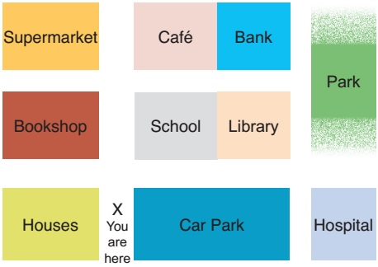

A: Excuse me! Is there a bank around here?
B: Yes, there is one near here. First, ........................

a) go along the street, take the second turning on the left. It’s on the left next to the bookshop.
b) take the first turning on the right. It’s on the left next to the school.
c) go along the street, take the second turning on the right. It’s on the left next to the cafe.
d) go along the street, take the second turning on the right. It’s on the right near the library.
SORU
1 | A | B | C | D
2 | A | B | C | D
3 | A | B | C | D
4 | A | B | C | D
5 | A | B | C | D
6 | A | B | C | D
7 | A | B | C | D
8 | A | B | C | D
9 | A | B | C | D
10 | A | B | C | D
11 | A | B | C | D
12 | A | B | C | D
13 | A | B | C | D
14 | A | B | C | D
15 | A | B | C | D
16 | A | B | C | D
17 | A | B | C | D
18 | A | B | C | D
19 | A | B | C | D
20 | A | B | C | D
21 | A | B | C | D
22 | A | B | C | D
23 | A | B | C | D
24 | A | B | C | D
25 | A | B | C | D
Süre 40 dakikadır.

