Yazilidayim.net
……………….. Secondary School 7th Grades 1st Term 2nd Written Exam
Name – Surname:__________________________ Class:_______ Number:______
A) Classify the given words in the box. (13x1=13)
» eagle
» snake
» cheetah

» shark
» hippo
» ostrich
» tortoise
» giraffe
» dolphin
» crocodile
» piranha

» kangaroo
» parrot

Reptiles
Fish
Birds
Mammals

B) Match the questions with the correct answers. (10x3=30)
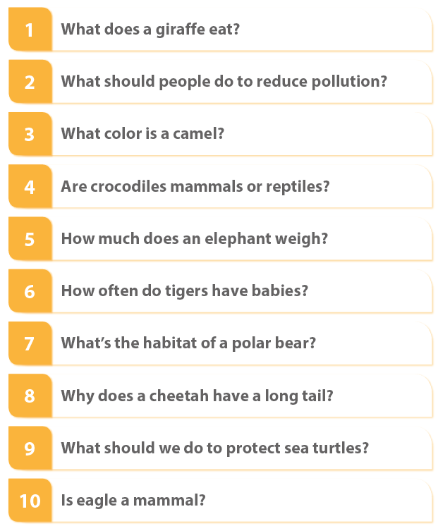
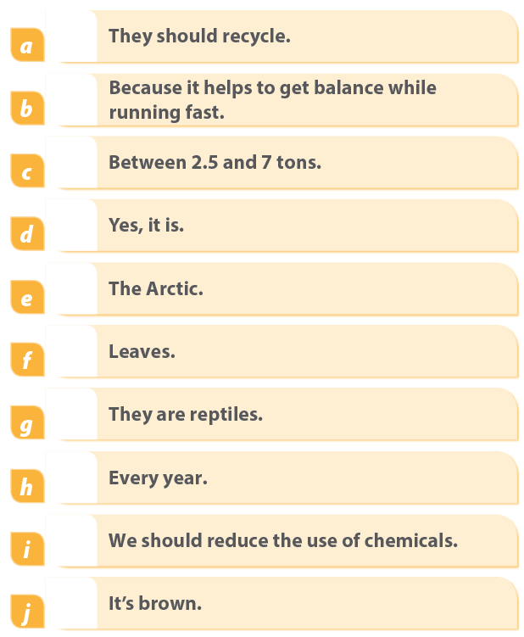

C) Write the past simple form of the given verbs. (14x1=14)
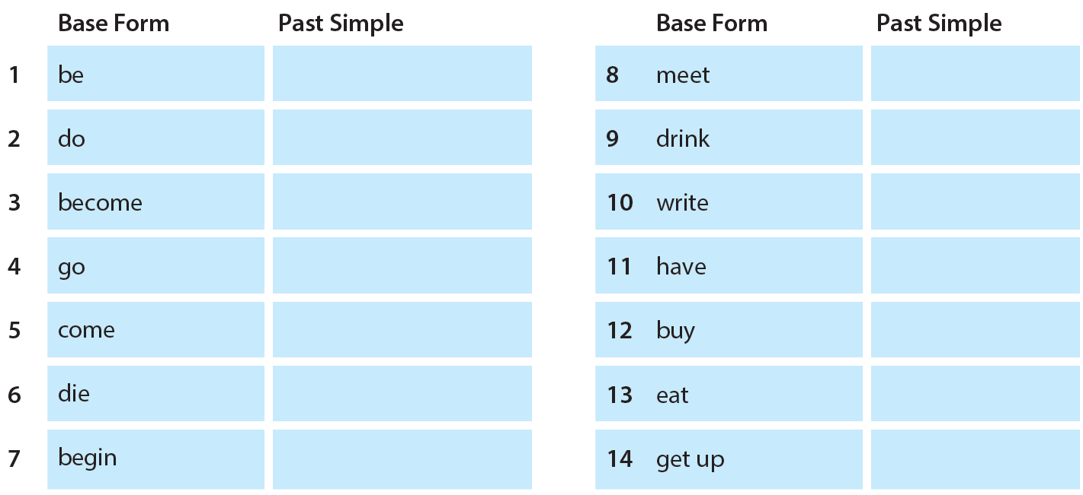

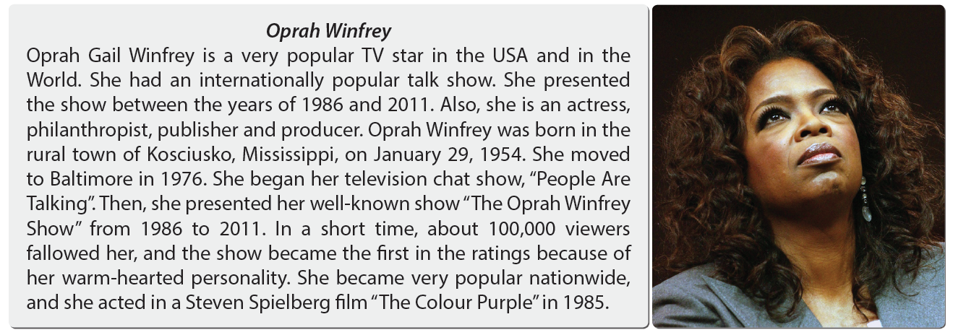

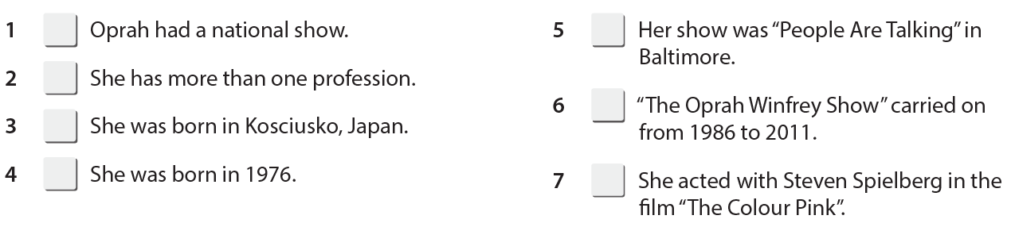
D) Read the text and write T (True), F (False) for the following statements. (7x2=14)

E) Match according to the text. (5x3=15)
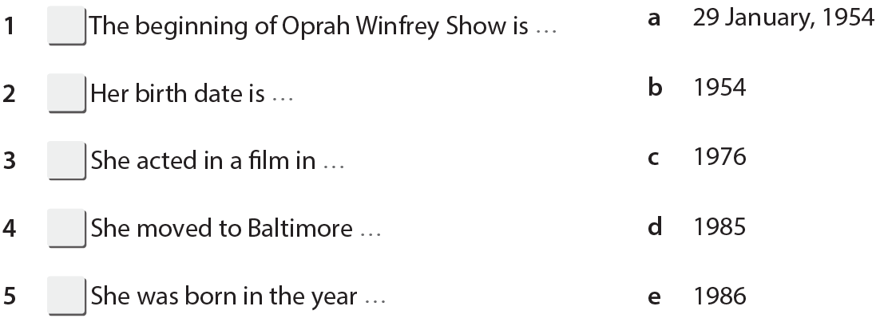

Yazilidayim.net

F) Fill in the blanks with the question words given below. (7x2=14)
