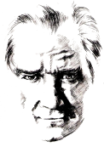 |  | …………….. SECONDARY SCHOOL  7TH GRADERS’ 1ST TERM 2ND WRITTEN EXAM
 | Name-Surname: Yazilidayim.net |  | Class-Number: | Mark:
A) Match the pictures with the words.(Resimlerle kelimeleri eşleştiriniz.)(6x1=6PTS)
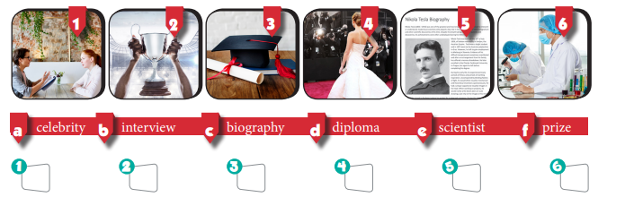
B)Read the biography and match.(Biyografiyi okuyunuz ve cümleleri resimlerle eşleştiriniz.(8x1=8PTS)
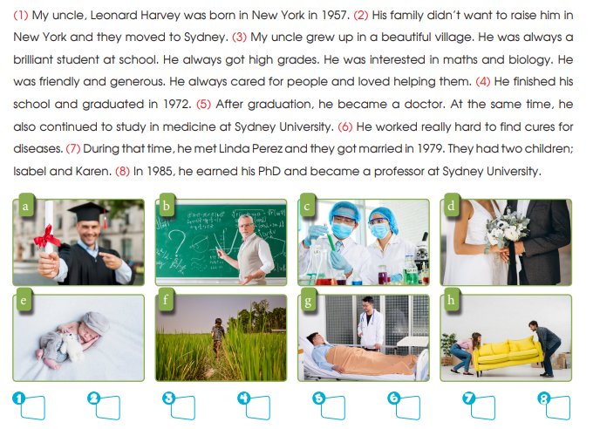C
C)TRUE –FALSE(DOĞRU-YANLIŞ)(Yukarıdaki biyografiye göre yapınız.)(5x1=5 PTS)
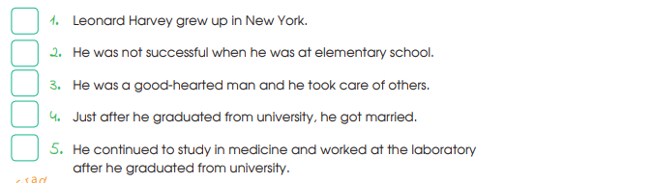
D)Read the text and answer the questions(Parçaya gore soruları yanıtlayınız.)(6x2=12 PTS)
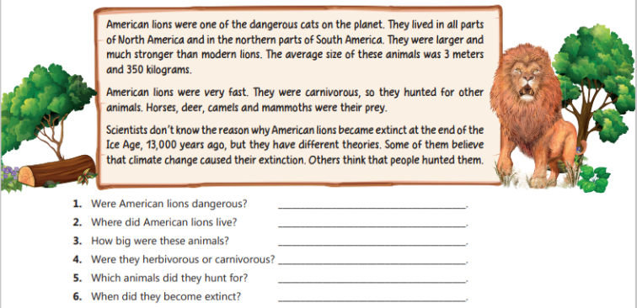

E
E)Match the words with the pictures(Resimlerle kelimeleri eşleştiriniz)(6x1=6 PTS)
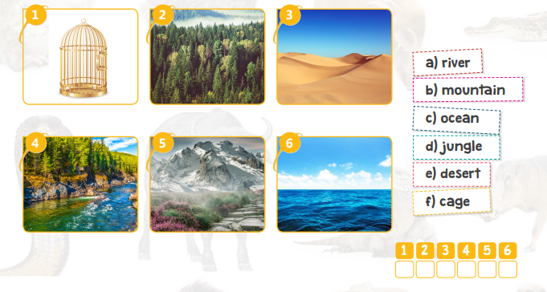
F)Circle the correct words(Doğru olanı yuvarlak içine alınız)(8x2=16 PTS)
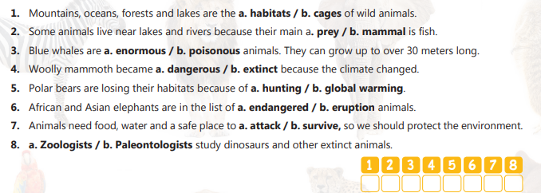

G)Match the animals with the information(Bilgilerle hayvan isimlerini eşleştiriniz.)(6X2=12 PTS)
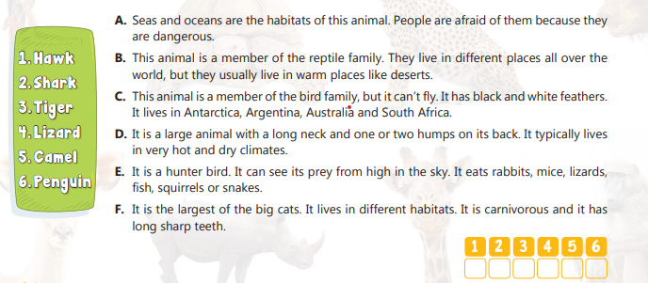
H)Complete the sentences with should/shouldn’t ( should/shouldn’t ile doldurunuz)(8x1=8 PTS)
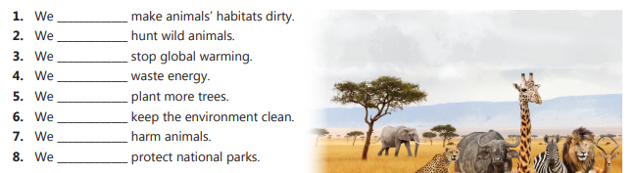
I)Circle the correct one.(Doğru olanı yuvarlak içine alınız.)(6x1=6 PTS)
1.Nick was born in Newcastle in 1970,but move /moved to Liverpool when he is /was five.
2.She has /had a great talent for maths when she was a child.
3.Naim Süleymanoğlu wins/won his first golden medal at the age of 15.
4.Acun Ilıcalı was 34 years old when he buys /bought a TV channel.
5.Aziz Sancar doesn’t/ didn’t graduate in 1980.He graduate/graduated from the university in 1969.
J)Match(Kelimeleri anlamlarıyla eşleştiriniz.)(20x1=20 PTS)
1.achievement | a)gelişmek | 1. | 1.become extinct | a)evcil | 1.
2.apprentice | b)şampiyona | 2. | 2.poisonous | b)kirletmek | 2.
3.author | c)evlenmek | 3. | 3.save | c)ömür | 3.
4.cadets | d)tanınmış | 4. | 4.survive | d)korumak | 4.
5.championship | e)başarı | 5. | 5.domestic | e)neden | 5.
6.develop | f)icat etmek | 6. | 6.life span | f)eğitmek | 6.
7.invent | g)keşfetmek | 7. | 7.reason | g)hayatta kalmak | 7.
8.discover | h)öğrenciler | 8. | 8.fur | h)zehirli | 8.
9.well known | i)çırak | 9. | 9.pollute | i)kürk | 9.
10.get married | j)yazar | 10. | 10.educate | j)nesli tükenmek | 10.
* GOOD LUCK *ÖZLEM KAPLAN ENGLISH LANGUAGE TEACHER

Yazilidayim.net

