

**SÜREYYA DEMİRKOL SECONDARY SCHOOL**

**Yazilidayim.net**

**ACADEMIC YEAR**

**6th CLASS 1st TERM 2nd ENGLISH EXAM**

Name-Surname : ………………………………………… Class : **6 /**…… Number : …….

**QUESTIONS / SORULAR**

1. **[Resimlerle cümleleri eşleştiriniz.](http://www.egitimhane.com/)** [( 8x3= 24 p )](http://www.egitimhane.com/)

**[](http://www.egitimhane.com/)**

1. [She is feeding her dog.](http://www.egitimhane.com/)
2. [He is running.](http://www.egitimhane.com/)
3. [She is resting.](http://www.egitimhane.com/)
4. [He is washing the car.](http://www.egitimhane.com/)
5. **[[](http://www.egitimhane.com/)](http://www.egitimhane.com/)**[She is knitting.](http://www.egitimhane.com/)
6. [He is drawing a picture.](http://www.egitimhane.com/)
7. [She is doing her homework.](http://www.egitimhane.com/)
8. **[[](http://www.egitimhane.com/)](http://www.egitimhane.com/)**[She is riding a horse.](http://www.egitimhane.com/)
9. **Resimlerin altına doğru hava durumunu yazınız.** ( 7x3= 21 p. )

|  |  |  |  |  |  |  |
| --- | --- | --- | --- | --- | --- | --- |
| **sunny** | **cloudy** | **windy** | **snowy** | **rainy** | **foggy** | **cold** |

[](http://www.egitimhane.com/)[](http://www.egitimhane.com/)



1. **Resimlerin altlarına uygun olanları yazınız.** ( 5x2= 10 p. )

|  |  |  |  |  |
| --- | --- | --- | --- | --- |
| **angry** | **scared** | **happy** | **sleepy** | **sad** |

[](http://www.egitimhane.com/)

1. **Resimlerin altlarına uygun olanlarını yazınız.** ( 5x3= 15 p. )



|  |  |  |  |  |
| --- | --- | --- | --- | --- |
| **Roller coaster** | **Bumper car** | **Ferris wheel** | **Carousel** | **Ghost train** |

[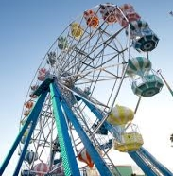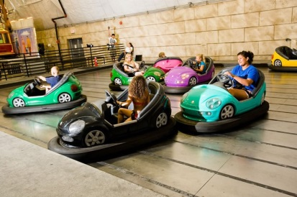](http://www.egitimhane.com/)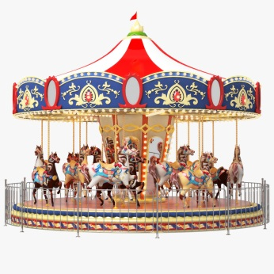[](http://www.egitimhane.com/)

**In summer, it is  and**

**I love  with my family.** ( 5 p. )

A) sunny / having a picnic

B) hailing / playing games

C) sunny / going outside

D) freezing / talking

**10. Aşağıdaki hava olaylarının doğru sıralanışı**

**hangi seçenekte verilmiştir.** ( 5 p. )

[](http://www.egitimhane.com/) 

A) sunny / windy / rainy B) rainy / windy / sunny

C) windy / sunny / rainy D) sunny / rainy / windy

[](http://www.egitimhane.com/)

**[11. What are they doing?](http://www.egitimhane.com/)** [( 5 p. )](http://www.egitimhane.com/)

|  |
| --- |
| [A)](http://www.egitimhane.com/)[They are waiting for the bus.](http://www.egitimhane.com/) |
| [B)](http://www.egitimhane.com/)[They are taking a nap.](http://www.egitimhane.com/) |
| [C) They are riding a bike..](http://www.egitimhane.com/) |
| [D)](http://www.egitimhane.com/)[They are having a snack.](http://www.egitimhane.com/) |

1. **[Verilen resime uygun olan kelimeyi seçiniz.](http://www.egitimhane.com/)** [( 5 p. )](http://www.egitimhane.com/)

**[I feel ……….. because it is stormy.](http://www.egitimhane.com/)** [( Korkmuş biri )](http://www.egitimhane.com/)

[[](http://www.egitimhane.com/)](http://www.egitimhane.com/)

1. [happy](http://www.egitimhane.com/)
2. [scared](http://www.egitimhane.com/)
3. [cold](http://www.egitimhane.com/)
4. [tall](http://www.egitimhane.com/)

**[12. I love going to ………………….](http://www.egitimhane.com/)** [( 5 p. )](http://www.egitimhane.com/)

[[](http://www.egitimhane.com/)](http://www.egitimhane.com/)

1. [Playground](http://www.egitimhane.com/)
2. [Skyscrapers](http://www.egitimhane.com/)
3. [Fun fair](http://www.egitimhane.com/)
4. [Kiosk](http://www.egitimhane.com/)
5. [](http://www.egitimhane.com/)**[Verilen resme uygun olan cümleyi seçiniz.](http://www.egitimhane.com/)** [( 5 p. )](http://www.egitimhane.com/)

**[](http://www.egitimhane.com/)**

[…………………](http://www.egitimhane.com/)

[…………………](http://www.egitimhane.com/)

[…………………](http://www.egitimhane.com/)

[A) It is hot and sunny.](http://www.egitimhane.com/)

[B) It is warm here today.](http://www.egitimhane.com/)

[C) It is freezing cold.](http://www.egitimhane.com/)

[D) It is rainy and wet.](http://www.egitimhane.com/)



…………………

…………………

…………………

…………………

…………………

GOOD LUCK…

Binnaz ERCİYES KARATAŞ

**Yazilidayim.net**

English Teacher