Yazilidayim.net
EDUCATION YEAR
MUSTAFA PASA SECONDARY SCHOOL 1st TERM 2nd ENGLISH EXAM
NAME&SURNAME: CLASS&NUMBER:
- Match the words with the pictures.(14 pts)

Downtown- traffic jam- skyscraper- kiosk- crowded- village- street

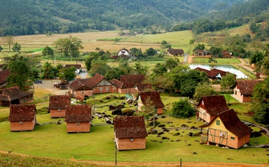
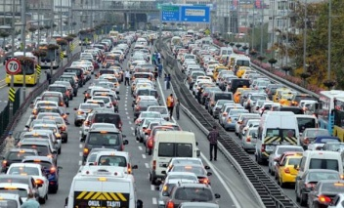
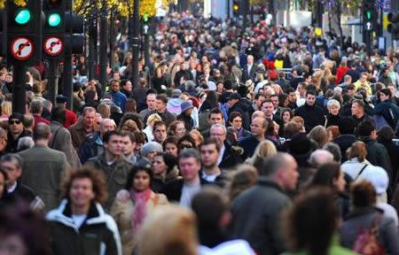
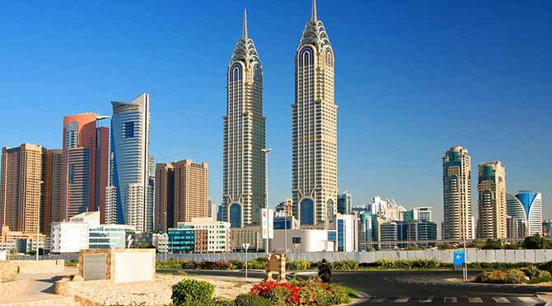
___________ _________________ ____________________ _______________

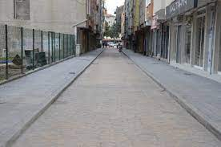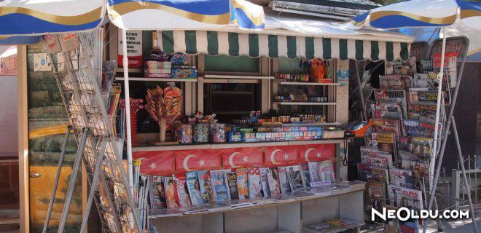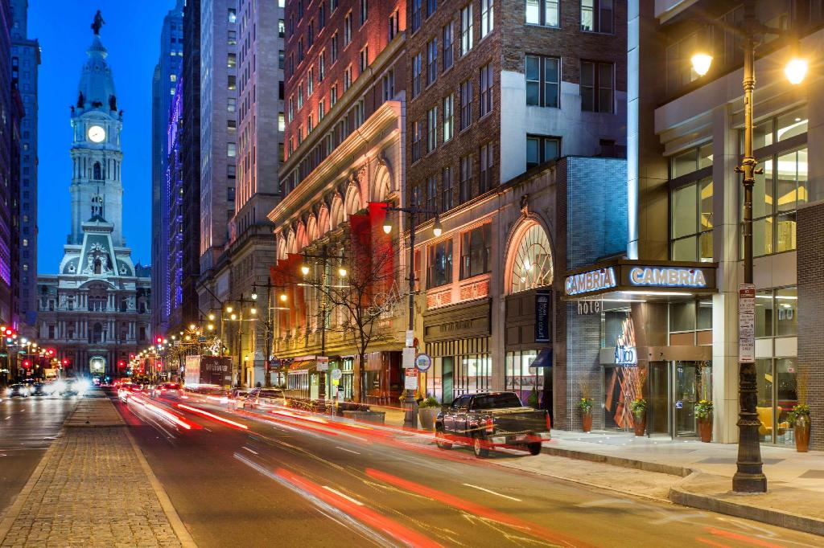

_________________________ _________________ __________________
B)Complete the Sentences Using the Present Continious Tense.(20 pts)
It’s a sunny day and I’m in the Blue Cafe. There are a lot of people here.Kate and Jack (1)______________(sit) at a table next to the door. Jack(2) _____________________(talk)on the phone and Kate(3)_____________(drink)tea. Sally and John(4) ________________(sit)outside the cafe and (5)_________________(watch) the street. Sally(6) _________________(eat) a hamburger and John(7) ____________________(drink)coffee. Alex(8) ________________(stand)next to David and Pam’s table. David(9) ________________(talk)to him and Pam(10)__________________(watch) the birds.
C)Complete the sentences by using Comparative Forms of the adjectives.(20 pts)
1. Antalya is _____________________(hot) Ankara.
2. Maths is _______________________(easy) English.
3.Cities are ______________________(crowded) villages.
4.Are you ________________________(thin) your friend?
5. I’m ___________________________(fat) my brother.
6. Big cities are ____________________(enjoyable) small towns.
7.I think city life is __________________(good)village life.
8.Skyscrapers are ____________________(high)apartment buildings.
9.Living in the village is ___________________(boring)living in the city.
10. January is _____________________(cold)April.
D)Answer the Question.
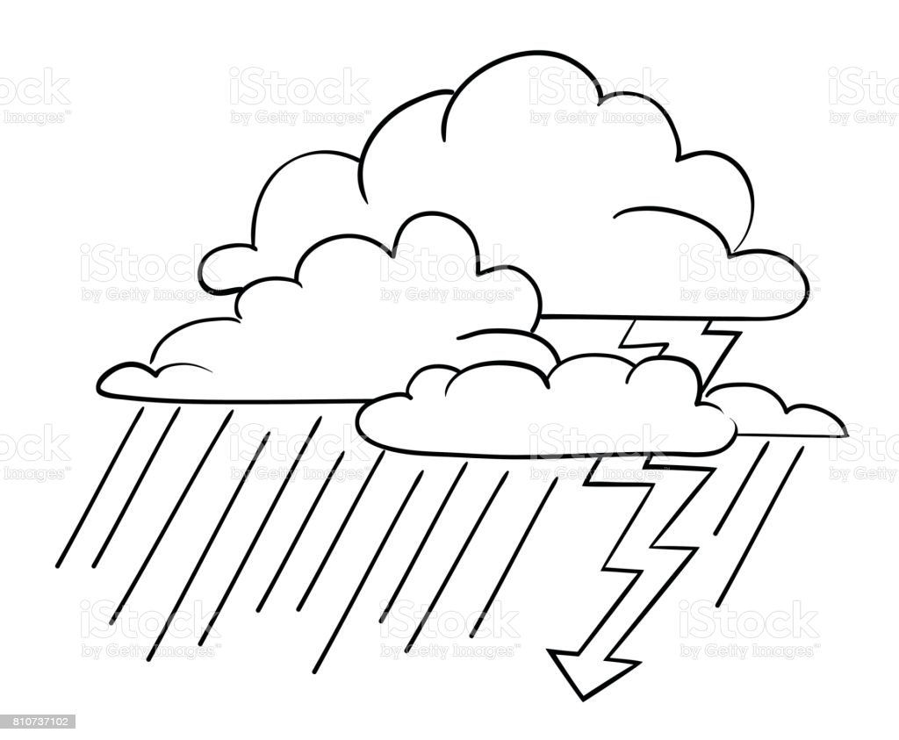
Which one is FALSE according to the table?(10 pts)
A)Tina feels moody in rainy weather.
Tina B)Helen feels anxious in snowy weather. C)Helen feels sleepy in stormy weather.
Helen D)Tina feels scared in stormy weather.

E) Read and Match.(14 pts)
- It’s rainy. Let’s (_____) A)fly our kites in the garden.
- It’s sunny. Let’s (_____) B)drive your car carefully.
- It’s snowy. What about (_____) C)wear your coat before you go.
- It’s windy. Let’s (_____) D)watch a DVD at home.
- It’s very hot. Do you want (_____) E)making a snowman?
- It’s very cold. You must (_____) F)play in the park.
- It’s foggy. You must (_____) G)to drink some lemonade?

LONDON
Monday |  | 15°C
Tuesday |  | 13°C
Wednesday |  | 12°C
Thursday |  | 10°C
F) According to the weather forecast, the weather is ___________________ in London.(10 pts)

A)hotter on Tuesday than on Monday.
B)cold and windy on Wednesday.
C)stormy on Tuesday.
D)snowy on Thursday.

G) According to the table, which one is FALSE?(6) H)Which student uses a FALSE emoticon?(6)
Jennifer | Thomas | Matt
15 | 12 | 14
160 cm | 152 cm | 156 cm
A)Sally: I feel scared.
B)David:I feel happy and energetic.
A)Thomas is younger than his friends.
B)Matt is shorter than Jennifer. C)Alex:I feel moody.
C)Matt is taller than Thomas.
D)Jennifer is older than her friends. D)John: I feel anxious.

BONUS QUESTION: Bir İngiliz ‘I feel blue’ diyorsa, ne demek istiyordur?(+5) PINAR T.

