|  |  |  |  |  |
| --- | --- | --- | --- | --- |
|  |  | ………………………**EDUCATIONAL YEAR**  **5TH GRADERS’ 1ST TERM 2ND WRITTEN EXAM\*** |  |  |

**Name/Surname: Yazilidayim.net Class/No:**

**A) Read the speech bubble and complete the map. (4x3= 12 Points)**

Hi, I’m Mehmet. Here’s a map of my neighbourhood. I live in a big house. There is a stationary behind my house. There is a grocery, a school and a bakery opposite my house. The school is between the bakery and the grocery. There is a cafè in the park.

|  |  |  |  |
| --- | --- | --- | --- |
|  | 1)……………………………… |  |  |
| Police Station | Mehmet’s House | Playground | Cinema |
|  | | | |
| 2)…………………… | 3)……………………… | Grocery |  |
|  |  |  | Park  4)……………………………… |

**B) Match. (6x2= 12 Points)**

1. hide and seek
2. keepy uppy
3. hopscotch
4. dodgeball
5. yoyo
6. origami

|  |  |  |  |  |  |
| --- | --- | --- | --- | --- | --- |
| Boy playing yoyo Premium Vector | playing dodgeball ile ilgili görsel sonucu | do origami cartoon ile ilgili görsel sonucu | Children playing hopscotch Premium Vector | keepie uppie ile ilgili görsel sonucu | playing hide and seek ile ilgili görsel sonucu |
|  |  |  |  |  |  |

**C) Read the texts below. Draw ☺ or ☹.(4x2= 8 Points)**

Ali lives in Kastamonu and his hobby is playing basketball with his friends. He also likes collecting stamps, but he doesn’t like playing soccer. At home, he plays computer games.

|  |  |  |  |
| --- | --- | --- | --- |
| People doing outdoor activities Free Vector | People doing outdoor activities Free Vector | playing computer games ile ilgili görsel sonucu | [Fotoğraf açıklaması yok.](https://www.sorubak.com/) |
|  |  |  |  |

**D) What time is it? (5x3=15 Points)**

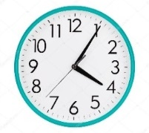 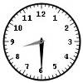 **[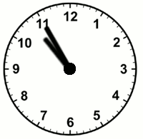](https://www.sorubak.com/)** 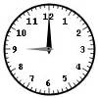 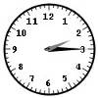

**E) Match the words.(5x3= 15 Points)**

1. brush teeth
2. get dressed
3. get up
4. go to school
5. play soccer

|  |  |  |  |  |
| --- | --- | --- | --- | --- |
|  |  |  |  |  |

1. **Match the words with the pictures. (7*2=14 points)**

**a-** Medicine **b-** Lemon and mint tea **c-** Plaster **d-** Bed **e-** Water **f-** doctor **g-** hospital

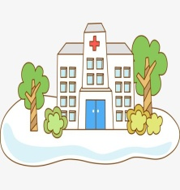 **[](https://www.sorubak.com/)  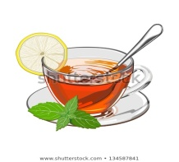 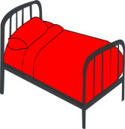  **

1. **Write the names of the people under their pictures. (6*2=12 points)**
2. My name is Ayşe. I have a stomachache.
3. My name is Ahmet. I have a sore throat.
4. My name is Merve. I have a fever.
5. My name is Osman. I have a broken arm.
6. My name is Elif. I have a headache.
7. My name is Murat. I have the flu.

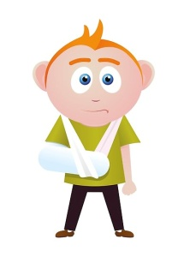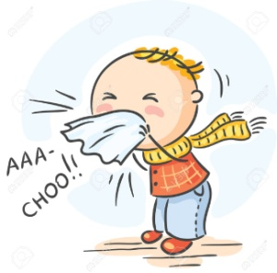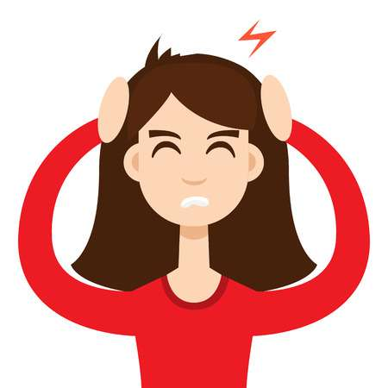  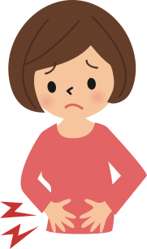

**1………………… 2………………….…… 3…………………………… 4………………………… 5…………………………6……………………**

1. **Answer the questions (4*3=12 points)**
2. **Where are you from? …………………………………………………….**
3. **What is your favourite class? ……………………………………………..**
4. **Do you have breakfast at home? ……………………………………………**
5. **What is your hobby / favourite game? ………………………………………**

**Yazilidayim.net**